Evaluating Machine Learning and Transformer-Based Models for Gujarati Sentiment Analysis
Manish Joshi¹, Snehlata Barde²
1 Faculty of Information Technology and Computer Science, Parul University, Vadodara, Gujarat., manishkumar.joshi42083@paruluniversity.ac.in
2 Parul Institute of Engineering and Technology, Parul University, Vadodara, Gujarat., snehlata.barde35880@paruluniversity.ac.in
Abstract
Gujarati has roughly 55 million speakers and very little sentiment analysis literature, and its one openly available corpus ships as tweet identifiers, not text. Fine-tuning, the standard way to use a pretrained encoder, therefore assumes resources this language does not reliably have. This paper asks instead how much sentiment-relevant structure four multilingual encoders already carry before any task-specific training. IndicBERT v1, IndicBERT v2, MuRIL and XLM-RoBERTa are frozen, their representations extracted in one inference pass, and small classical classifiers fitted on top against character- and word-level lexical baselines, across a translated product-review corpus (1,151 texts) and a natively written movie-review corpus (453 texts). Every score is a mean with its spread over 50 cross-validation folds, and every comparison is corrected for the folds being re-splits of one corpus. One result survives every check: IndicBERT v2 with mean pooling reaches 0.9130 ± 0.0163 macro F1 on the product corpus, 0.0512 above the strongest lexical baseline at a corrected p = 0.000125. On the native corpus no encoder separates from character n-grams, and a power analysis bounds any such advantage at roughly 0.07 macro F1 rather than establishing its absence. Cross-domain transfer reaches 0.8092 ± 0.0173 without significance. The apparent translated-versus-native contrast fails an interaction test under four variants and is reported as a hypothesis, since the corpora differ in origin, composition language, polarity balance and length at once. Mean pooling beats CLS pooling in all sixteen encoder-task pairs, and the published fine-tuned ranking of these models inverts when they are frozen.
Keywords: Gujarati; sentiment analysis; low-resource languages; frozen representations; multilingual encoders; statistical significance
1. Introduction
Gujarati has around 55 million first-language speakers and almost no sentiment analysis literature. A recent catalogue of South Asian language research found 21 Gujarati papers published between January 2022 and October 2024 across every task in text, speech and vision combined [3]. Of the sentiment datasets built for the language over the past decade, one is openly available [1], and it is distributed as tweet identifiers rather than text, so reconstructing it now requires paid API access to a decade-old collection that has since lost items to deletion and account changes.
Meanwhile the encoders are already there. IndicBERT [6], MuRIL [7], IndicBERT v2 [8] and XLM-R all include Gujarati in their pretraining, and the standard way to use them is to fine-tune one on a labelled corpus. That recipe assumes the two things Gujarati does not reliably have: a corpus to fine-tune on, and the compute budget to do it repeatedly enough to know whether the result is stable. Gokani and Mamidi [1] followed it and reported single-run fine-tuned scores topping out at 0.66 macro F1, with the two general-purpose multilingual encoders falling below a bag-of-words baseline.
This paper asks a different question, and it is the question a practitioner with no labelled data and no GPU actually faces: how much sentiment-relevant structure do these encoders already carry, before any task-specific training? We freeze each encoder, extract sentence representations in a single inference pass, and fit small classical classifiers on top of them. No transformer parameter is updated anywhere in this work.
The regime is chosen for what it makes affordable. Because only a logistic regression retrains per split, the entire grid can be re-run 50 times, which is what allows every number here to be reported as a mean with its spread across resamples. No published Gujarati sentiment study reports variance at all, and the field's own methodological literature has been asking for it for a decade [23]. It also allows the statistical machinery to be applied properly rather than gestured at: the resamples are re-splits of one corpus and are therefore not independent, so every p-value in this paper is corrected accordingly [24].
We evaluate four frozen encoders under two pooling strategies against three lexical baselines, across two Gujarati corpora, four tasks and a cross-domain transfer arm, with a zero-shot model as the floor. Results are reported over 10×5-fold cross-validation (50 estimates), with the original 10-seed holdout run retained as a robustness check; the two protocols agree on every conclusion.
Five contributions follow, and two of them are negative.
C1, a frozen-representation benchmark for Gujarati sentiment, with variance. Four encoders, two poolings, three lexical baselines and four classical heads over two corpora. MuRIL has not previously been evaluated on Gujarati sentiment in any work we could find, and no prior Gujarati study reports a spread across runs. We also report subword statistics per tokenizer, which nothing published for this language does.
C2, one result that survives every check. IndicBERT v2 with mean pooling and logistic regression reaches 0.9130 ± 0.0163 macro F1 on the translated product corpus, +0.0512 over the strongest lexical baseline, at a corrected p = 0.000125. It beats all three lexical baselines under Holm correction and survives choosing the winner on one half of the splits and testing it on the other. This is the paper's one unambiguous positive finding, and it is deliberately stated narrowly: one encoder, one corpus.
C3, two bounded nulls, and a headline we had to withdraw. On the natively written movie corpus the best frozen encoder leads the strongest lexical baseline by +0.0219 (3-class) and +0.0165 (binary), and neither survives correction (p = 0.463 and 0.508). We had intended to report that frozen encoders separate from lexical features on translated Gujarati but not on native Gujarati. That sentence compares two p-values, which tests nothing. Tested properly, as an interaction between the two gaps, the difference is +0.0347 at a corrected p = 0.213, and it fails to reach significance under all four ways of choosing the transformer side. It appears in this paper as a hypothesis with a bound attached, never as a result. The bound matters: these arms could only have detected true gaps of 0.0845 and 0.0706 respectively, so what we can honestly say is that any advantage on native Gujarati is smaller than roughly 0.07 macro F1, not that there is none.
C4, the first cross-domain transfer test for Gujarati sentiment. A classifier trained only on product reviews and tested on movie reviews reaches 0.8092 ± 0.0173, about 96% of the in-domain ceiling on the same target. Its margin over the lexical baseline is +0.0040 with a confidence interval spanning zero, so no significance is claimed for the comparison; the score stands on its own.
C5, a zero-shot floor that is really a boundary condition. A multilingual tweet-sentiment model applied with no training reaches 0.8537 ± 0.0222 on the product corpus, beating both word-level lexical baselines with zero Gujarati supervision. On the movie corpus it scores 0.1321, because it assigns "Neutral" to 452 of 453 reviews. That is the score of a degenerate classifier rather than an inaccurate one, so the predicted-class histograms ship beside the number.
One result cuts across all five. Ranking under fine-tuning does not predict ranking as a frozen representation. IndicBERT, the best fine-tuned model in the published Gujarati baselines [1], is the weakest of our four encoders on every task, losing even to bag-of-words. Tokenisation does not explain it: IndicBERT v1 and XLM-R fragment Gujarati almost identically, and they sit at opposite ends of our results in the opposite order to theirs. Separately, mean pooling beats CLS pooling in all sixteen encoder-task pairs, which is a concrete recommendation for anyone using these encoders frozen.
The paper is deliberate about what it does not claim. It reports no state of the art, and its absolute scores are not comparable to fine-tuned systems. It makes no comparison against the published GSAC baselines, which were measured on a different corpus under a different regime. And it does not attribute the difference between its two corpora to translation: as Section 3.3 sets out, those corpora differ along four axes at once, and this design cannot separate them.
The rest of the paper is organised as follows. Section 2 reviews Gujarati and Indic sentiment resources, the encoders evaluated here, probing practice, translated-corpus effects, cross-domain transfer, and the reporting conventions this paper follows. Section 3 describes the corpora, cleaning and tokenisation. Section 4 gives the methodology, including the significance and power machinery. Section 5 states the experimental setup. Section 6 reports the results. Section 7 discusses what the translated-versus-native contrast can and cannot support, and states the limitations. Section 8 concludes.
2. Literature Review
Six bodies of work bear on this paper: sentiment analysis in Gujarati and the resources it has to work with, the pretrained encoders we evaluate, the practice of probing frozen representations, the effects of translated text on model behaviour, cross-domain sentiment transfer, and the reporting conventions that govern how a small-corpus result may be stated.
2.1 Sentiment Analysis in Gujarati
Gujarati has roughly 55 million first-language speakers [3] and very little published sentiment work to match. Gokani and Mamidi [1] survey what exists and find a consistent pattern: the datasets are small and none of them are released. Their Table 1 lists a 40-tweet study from 2017, a 1,120-tweet corpus built around a Gujarati SentiWordNet, a 300-poem emotion set, and two movie-review collections of 500 and 2,085 items, the larger of which was expanded by translating English reviews into Gujarati. None is openly available, so none of the reported results can be reproduced or used as a comparison point.
GSAC [1] was built to break that pattern. It contains 6,575 tweets annotated by four native speakers and is the one open-access Gujarati sentiment corpus. Its baselines, reported on the test split, place fine-tuned IndicBERT highest at 0.66 macro F1, followed by GujaratiBERT at 0.64 and XLM-T at 0.63. Two general-purpose multilingual encoders sit far below: XLM-RoBERTa reaches 0.39 and mBERT 0.38, both under the 0.56 obtained by bag-of-words with Naive Bayes. Gokani and Mamidi attribute the gap to how little Gujarati data those two models saw during pretraining, and they note that XLM-T stays competitive on a Gujarati sample of only about 10,000 tweets out of 198M, which they read as evidence that domain match matters as much as language coverage.
GSAC is distributed as tweet identifiers and labels rather than text, following Twitter's privacy terms, so using it now requires rehydration through an API whose academic tier no longer exists. The corpus also spans August 2010 to February 2022, and old social-media collections lose a substantial fraction of their items to deletion and account changes. Any rehydrated version is therefore smaller than the published one and is not the corpus the baselines in [1] were measured on. We consequently treat GSAC's numbers as context and never as a comparison against ours.
Two recent surveys confirm how thin the surrounding literature is. Gupta [3] catalogues South Asian language research published between January 2022 and October 2024 and finds 21 Gujarati papers in total, spread across sentiment analysis, hate speech detection, summarisation, machine translation, handwriting recognition and speech. Kumar et al. [4] consolidate more than 200 Indian-language datasets by task and reach the same conclusion about uneven coverage across languages. Work on low-resource sentiment continues to move toward richer settings, such as the multimodal cross-lingual transfer framework of Chen et al. [5], while the monolingual text case for Gujarati remains largely unmeasured.
Three gaps follow from this. No published Gujarati sentiment study reports variance across runs; every number in the literature is a single fit. We found no evaluation of MuRIL [7] on Gujarati sentiment at all. And no study tests whether a Gujarati sentiment model transfers between domains, although several domains are now available separately.
2.2 Pretrained Encoders for Indic Languages
The four encoders evaluated here come from two design traditions. Kakwani et al. [6] released IndicBERT as part of IndicNLPSuite, training a compact ALBERT model on 8.8 billion tokens of news-crawl text across 11 Indian languages and packaging it with the IndicGLUE evaluation suite. Khanuja et al. [7] built MuRIL for 17 languages, 16 Indian ones plus English, and added a translation language modelling objective on top of masked language modelling so that translated and transliterated document pairs act as cross-lingual supervision during pretraining. Doddapaneni et al. [8] extended the first line with IndicCorp, a 20.9-billion-token corpus covering 24 languages from four families, the IndicXTREME benchmark of nine tasks over 20 languages, and IndicBERT v2, which gains two absolute points over their strong baseline when averaged across languages and tasks.
That work also reports tokenizer fertility, and the ordering is relevant to our results in Section 6: mBERT fragments Indic text most at 2.8 subwords per word, XLM-R follows at 2.2, and MuRIL and IndicBERT both reach 1.7 [8]. Aggarwal et al. [9] evaluate the same family of models from the other direction, fine-tuning IndicBERT, MuRIL, mBERT and XLM-RoBERTa on IndicXNLI, an inference set produced by machine-translating XNLI into 11 Indic languages.
Every evaluation above fine-tunes. What none of them report is how much task-relevant structure these encoders carry before any task-specific training, which is the quantity this paper measures.
2.3 Probing Frozen Representations
Reading a fixed encoder through a small trained classifier is the standard probing setup, and two results shape how we designed ours. Eger et al. [10] ran the first large study of probing design choices in low-resource conditions and found that the size of the probing set and the choice of classifier can change which encoder appears best. They identify a stable region of settings for English, apply it to other languages, and find that the English rankings do not carry over. Choenni and Shutova [11] probe LASER, mBERT, XLM and XLM-R for typological properties and show that what an encoder retains depends on its pretraining objective, and that the information is distributed unevenly across layers.
Both findings argue against reading a single probe as a property of the encoder. We therefore vary the classifier across several families, report every score over repeated resamples, and treat the pooling choice as one of the measured variables.
2.4 Translated Text and Its Effects on Models
Translated text differs systematically from text originally written in the same language, and the difference is measurable. Wein et al. [15] fine-tune foundation models to decide whether an English text was written or translated and reach 94% macro F1, against roughly 50% for human judges; their interpretability analysis finds that pretrained models detect these cues without any fine-tuning. Kunz [16] trains small language models on English translated from 24 source languages and shows that the source language leaves a signature, with general perplexity tracking the lexical diversity of the translated corpus and grammatical performance tracking typological similarity to English.
The downstream consequences have been documented across tasks. Chowdhury et al. [12] remove translationese from embedding space with iterative null-space projection and improve natural language inference accuracy as a result. Yu et al. [13] find that translation artifacts follow common patterns across languages, model those patterns explicitly, and improve translate-train performance on multilingual question answering. Park et al. [14] show the same effect in cross-lingual visual question answering, where a model answers a human-written question correctly and the same question in translation incorrectly.
Against this, Kumar et al. [2] argue the opposite case for Indian languages. They machine-translate Sentiment140 into 22 Indian languages with Google Translate and report that the translated corpora retain the sentiment characteristics of the source and preserve enough sequential structure to train on, which they take as evidence that translation is a workable foundation for low-resource sentiment analysis. Their own limitations section notes untranslated English left in the output and the absence of any human-translated reference against which the translation quality could be checked.
One of the two corpora used here comes from this territory. The IndicSentiment set released with IndicXTREME [8] is not a collection of naturally occurring reviews: annotators listed the aspects that matter for each product category, a second group wrote positive and negative reviews against those aspects, and every review was composed in English and then manually translated into 13 Indic languages by two annotators per language. Section 3 describes what this means for the comparison, and Section 7 sets out why the design cannot isolate translation as the cause of the contrast we observe.
2.5 Cross-Domain Sentiment Transfer
Sentiment vocabulary is domain-specific, and the standard response is to adapt. Yang et al. [18] learn high-level features that generalise across domains so that a single classifier can be trained on documents pooled from several of them, without requiring labels from every domain. Du et al. [17] post-train BERT with a target-domain masked language modelling task and a domain-distinguishing task, then apply adversarial training to obtain domain-invariant features, and report gains on the Amazon review benchmark. Guo et al. [20] handle multiple sources at once with a mixture of experts, weighting each source predictor by a learned point-to-set distance to the target example, which lets the model resist negative transfer from a poorly matched source.
Lai et al. [19] make the distinction that matters most here: in cross-lingual document classification, the domain gap is separate from the language gap, and closing the language gap alone leaves accuracy on the table.
All four methods use target-domain data, labelled or unlabelled, to close the gap. Our transfer arm does not adapt at all. It trains on one corpus and tests on the other so that the size of the gap can be measured rather than reduced, which is the prior question for a language where no cross-domain measurement exists.
2.6 Variance, Significance and Power
Reimers and Gurevych [23] evaluated 50,000 LSTM networks over five sequence tagging tasks and showed that the random seed alone produces differences significant at p < 10⁻⁴, with an absolute spread of about one F1 point on named entity recognition, enough to move a system between state of the art and mediocre. They argue for reporting score distributions instead of single numbers. This is the practice the Gujarati literature has not adopted.
Dror et al. [21] set out a protocol for choosing a significance test from the properties of the task and the evaluation measure, and their survey of ACL and TACL papers from 2017 found significance testing frequently omitted or applied incorrectly. Card et al. [22] address the complementary question of power. Their meta-analysis finds underpowered experiments common in NLP, with test sets on several GLUE tasks small enough that most comparisons against state of the art cannot detect the differences being claimed, and machine translation test sets of 2,000 sentences reaching only about 75% power for a one-BLEU difference.
Both concerns bind here. The native Gujarati corpus used in this paper holds 453 texts, and 340 in its binary form, so the detectable effect size is large relative to the differences under test. Section 5 states the resampling protocol and the variance correction applied to it, and Section 6 reports what each null result can and cannot rule out.
3. Dataset and Preprocessing
3.1 Corpus Selection
The constraint that decided this paper's data is the one described in Section 2: the only open Gujarati sentiment corpus, GSAC [1], is distributed as tweet identifiers rather than text. We therefore built the study on the two Gujarati sentiment resources whose text can be downloaded and checked, and we record the checksum of each file so that the corpus a reader reconstructs is the corpus we measured.
The first is the Gujarati portion of IndicSentiment, released with IndicXTREME [8]. It supplies 1,000 test rows and 156 validation rows, labelled Positive or Negative, and we use both splits because no fine-tuning happens here and there is no reason to hold one out. We refer to it throughout as the product corpus.
How it was built matters more than its domain label, and Section 2.4 gives the reason. Doddapaneni et al. [8] curated a list of aspects for each product category, then asked a separate group of annotators to write reviews against a subset of those aspects, with instructions to produce both positive and negative reviews for each product. Every review was composed in English and then manually translated into 13 Indic languages by two annotators per language. The corpus is therefore synthetic text written to a template, balanced by construction, and translated rather than composed in Gujarati. The same paper notes in its own analysis that product reviews are a one-dimensional genre in which most items are strongly polarised.
The second corpus is nikitadesai/gujaratiMovieSentiments, 454 rows of Gujarati movie reviews labelled Negative, Neutral or Positive. These are ordinary reviews written in Gujarati, and we refer to them as the movie corpus. Its provenance is documented far less than the product corpus, which is itself a fact about the state of Gujarati resources.
3.2 Cleaning
Loading is done in one module, code/dataset.py, which is the only place in the pipeline where a corpus count is computed. An earlier loader reported 1,127 movie rows where the file holds 454, and the error was caught because the count had a single owner. Rows are discarded for three reasons and each discard is recorded.
Two rows of the IndicSentiment test split carry Gujarati text with LABEL: null. They are unlabelled rather than mislabelled, so they cannot be repaired and are dropped. Three further product rows are exact duplicates of another row's text; a duplicate that lands on opposite sides of a split leaks its label and inflates every score computed afterwards, so only the first occurrence is kept. The movie CSV contains one malformed row in which the sentiment legend leaked into the label column.
The files hold 1,610 rows and the usable corpus is 1,604 texts. Table 1 gives the composition. Both numbers appear in the paper because only one of them can be trained on.
Table 1. Corpus composition after cleaning. Counts are produced by code/dataset.py and are the only counts used anywhere in this paper.
Corpus | Texts | Class counts | Dropped | Reason
product | 1,151 | 572 Neg / 579 Pos | 5 | 2 unlabelled, 3 duplicate texts
movie | 453 | 134 Neg / 113 Neut / 206 Pos | 1 | legend row in the label column
movie_binary | 340 | 134 Neg / 206 Pos | — | Neutral removed to match label spaces

The corpus itself receives no normalisation beyond whitespace trimming, and no stopword list or stemmer is applied anywhere in the pipeline. Neither exists in a validated form for Gujarati, and applying one to the lexical baselines but not to the transformers would make the comparison unequal. The lexical baselines of Section 5 keep scikit-learn's default case folding, which is inert on Gujarati script and affects only the Latin characters that appear inside some reviews.
movie_binary is a view of the movie corpus with the Neutral class removed. It exists for the transfer arm: the product corpus is binary, so a classifier trained on it can only be tested against a binary label space. It also answers a question that would otherwise confound the comparison, namely whether the movie corpus is harder only because it has three classes.
3.3 What the Two Corpora Do Not Share
The product and movie corpora differ along four axes at once, and the design cannot separate them. Table 2 sets them out. It belongs here, ahead of any result, because it constrains what the numbers in Section 6 are allowed to mean: a difference in performance between the two corpora cannot be attributed to translation, to genre, to polarity balance or to length individually, and Section 7 says so again where the temptation to attribute it is strongest.
Table 2. The axes along which the two corpora differ. Character lengths are computed by code/dataset.py.
 | product | movie
Origin | commissioned against an aspect template | reviews written for their own sake
Composed in | English, then manually translated | Gujarati
Polarity | balanced by construction | naturally distributed, includes Neutral
Length | mean 130 characters, max 551 | mean 1,301 characters, max 2,977
Classes | 2 | 3, and 2 in movie_binary

3.4 Tokenisation
Subword tokenisation is reported here for two reasons. It sets the windowing policy of Section 3.5, and no published Gujarati study reports it, so the measurement is a small contribution in its own right. Each tokenizer was run at the same pinned model revision used for embedding extraction: ai4bharat/indic-bert at 4842dd25, ai4bharat/IndicBERTv2-MLM-only at 8598f13f, google/muril-base-cased at afd9f36c, and FacebookAI/xlm-roberta-base at e73636d4. We pin revisions because an unpinned cache was found holding MuRIL weights taken from an unmerged pull request branch.
Table 3. Subword statistics per tokenizer, measured at the pinned revisions. The last column is the share of movie reviews exceeding the 512-token model limit.
Model | Vocabulary | product mean | movie mean | movie > 512
IndicBERT v1 | 200,000 | 46.7 | 434.7 | 29.8%
IndicBERT v2 | 250,000 | 34.9 | 335.0 | 11.5%
MuRIL | 197,258 | 37.4 | 374.0 | 17.4%
XLM-R | 250,002 | 46.3 | 453.3 | 32.9%

IndicBERT v2 is the outlier. It encodes the same Gujarati text in roughly a quarter fewer subwords than IndicBERT v1 or XLM-R, which fragment the movie corpus almost identically at 434.7 and 453.3 tokens per review. Fig. 4 plots the full length distributions. Section 6.8 returns to this, because the two models with near-identical fertility sit at opposite ends of the results.
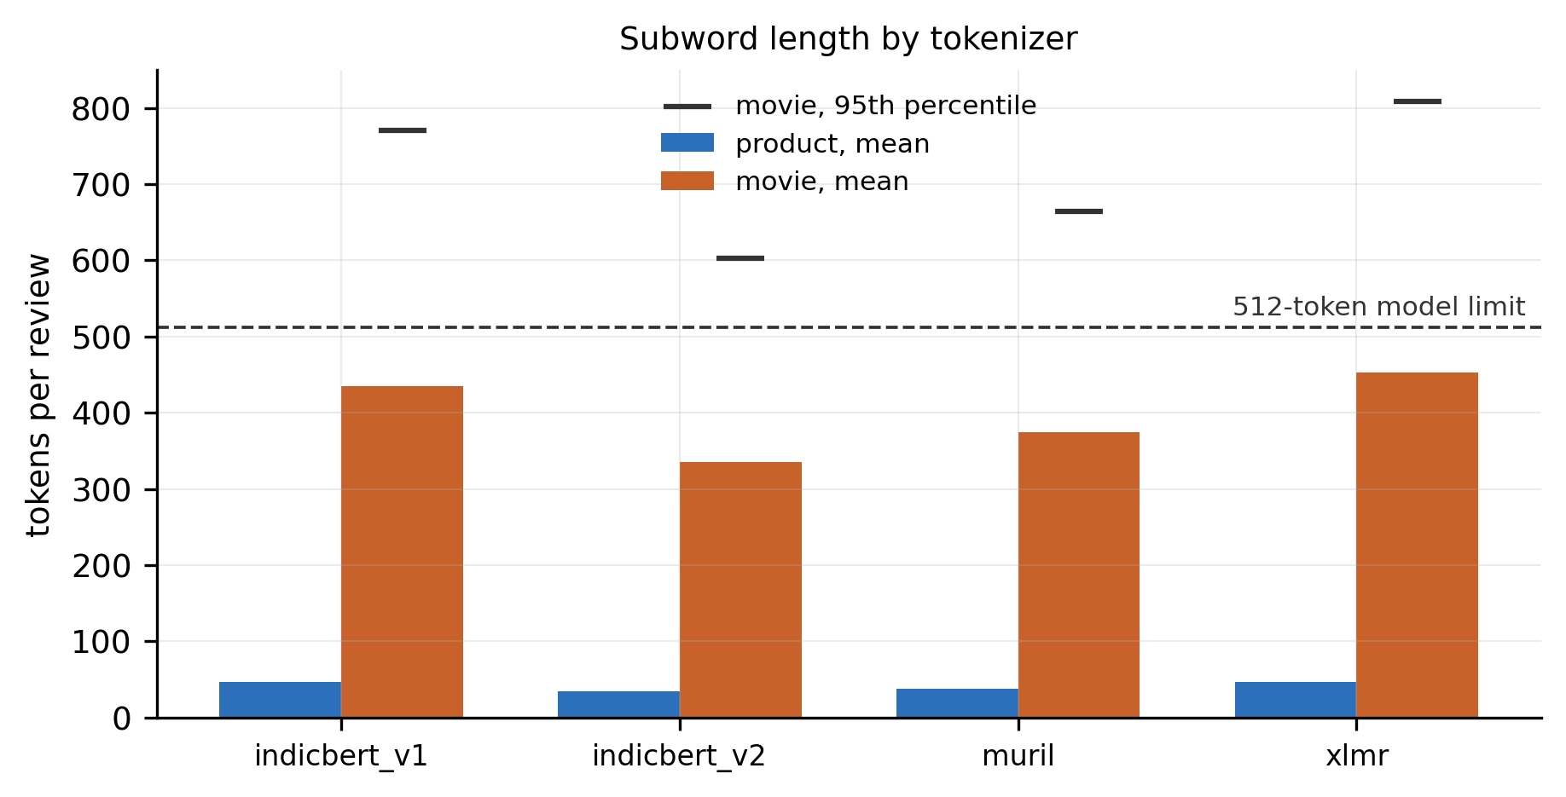
Fig. 4. Subword sequence length per tokenizer on both corpora, showing why windowing at 512 tokens was necessary and how differently the four vocabularies fragment Gujarati.
3.5 Windowing
An early benchmark of extraction cost used a 128-token cap, which is a common default and would have been a silent disaster on this data. Between 96.9% and 98.9% of movie reviews exceed 128 subwords depending on the tokenizer, so nearly every movie review would have been truncated with no error raised and no trace in the output. The product corpus hides this: at most 1.3% of product reviews exceed the same cap.
Texts longer than the 512-token model limit are therefore split into consecutive non-overlapping windows and every window is encoded. Mean-pooled representations are recombined across a text's windows with a weighting proportional to each window's token count, so a review's tail contributes in proportion to its length and no text loses content. The CLS representation is taken from the first window only, because a CLS vector from a later window is a summary of a fragment that never began the document. Under this policy the share of movie reviews needing more than one window matches the last column of Table 3, and no product review needs a second window under any of the four tokenizers.
4. Methodology
4.1 The Frozen-Representation Regime
Every arm of this study reads a fixed encoder and trains something small on top of it. No transformer parameter is updated at any point, and no encoder sees a sentiment label. Each model runs once in inference mode over each corpus, its sentence representations are cached to disk, and every later experiment reads a NumPy array.
Two consequences follow, and both shape what the paper can say. The comparison is between representations, not between fine-tuning recipes, so the absolute scores here are not comparable to a fine-tuned system's and no such comparison is drawn. And because only a small classifier retrains per split, the full grid is affordable to run 50 times, which is what makes the variance reporting of Section 4.6 possible at all. Eger et al. [10] show that in low-resource probing the classifier and the amount of probing data are themselves part of the measurement, so the design below varies both rather than fixing one configuration and reporting it as the property of the encoder.
4.2 Feature Sets
Eleven feature sets are compared on each task. Eight are transformer representations: four encoders under two pooling strategies. Three are lexical baselines.
Mean pooling averages the final hidden states over the attention mask, so padding contributes nothing. For a text split into several windows, the per-window means are recombined weighted by each window's real token count, so a long review's tail counts in proportion to its length. CLS pooling takes the first-position vector of the first window only, since a CLS vector drawn from a later window summarises a fragment that never began the document.
The three lexical baselines are word-level TF-IDF over unigrams and bigrams, character-level TF-IDF over char_wb n-grams of length 2 to 5, and a bag-of-words count model over unigrams and bigrams, each capped at 20,000 features with sublinear term-frequency scaling on the TF-IDF variants. The character n-gram baseline is not filler. Gujarati is morphologically rich, so word-level features scatter across inflected surface forms that share a stem, and character n-grams are the standard counter to that. It is consistently the strongest lexical baseline in our results, which is why every comparison in Section 6 is read against the strongest lexical baseline for that task rather than against a fixed one.
4.3 Classification Heads
Four heads are used across the study: logistic regression, a linear support vector classifier, a random forest of 300 trees, and gradient boosting. The first three are fitted on every feature set under both protocols; the fourth is restricted as described below. All four carry balanced class weights, because the movie corpus runs 134/113/206 and the published Gujarati work neither balances it nor reports the gap between macro and weighted F1. Gradient boosting has no class-weight parameter and receives equivalent per-sample weights instead.
Gradient boosting appears in the holdout protocol only. It lost 42 of 44 cells while consuming 86% of that run's fit time, and expanding it to 50 folds would have turned a 43-minute job into roughly 4.8 hours to refine a baseline that was already losing. It keeps its holdout numbers and its baseline row, and the exclusion is recorded in the run manifest rather than left implicit.
Dense transformer features are standardised before the linear heads, which need it and which the trees are indifferent to.
4.4 Leakage Control
Every vectoriser and every scaler is fitted inside the training fold and applied to the test fold, never fitted on the full corpus. TF-IDF fitted before splitting would let test-set vocabulary and document frequencies inform the training representation, and that leak is small, silent and always flattering. Exact duplicate texts are removed at load time for the same reason (Section 3.2): a duplicate straddling a split leaks its own label.
4.5 Tasks
Four tasks are evaluated. Three are in-domain: product (binary, translated), movie (three-class, natively written) and movie_binary (the movie corpus with Neutral removed). The fourth is cross-domain transfer, training on the product corpus and testing on movie_binary.
movie_binary exists for two reasons. It matches the label space so that a product-trained classifier can be tested on movie reviews at all, and it rules out the alternative explanation that the movie corpus is harder only because it has an extra class. Both binary tasks also make the interaction test of Section 4.8 interpretable, since label-space size is then not a confound.
4.6 Resampling
Results are reported under two protocols, and the paper states the conclusions of both.
The primary protocol is 10 repeats of stratified 5-fold cross-validation, giving 50 estimates in which every text serves as test data exactly once per repeat. The secondary protocol is 10 stratified 80/20 holdout splits. Both hold the train/test ratio at 80/20, so the two differ in how many estimates they produce and not in how much data each fit sees.
The seed moves the split, not only the classifier. Re-seeding a logistic regression on fixed data is deterministic and would report a standard deviation of exactly 0.000, rigorous-looking and measuring nothing. Here the seed drives the stratified split, so the reported spread is the quantity a reader cares about: how far the score moves when the data is cut differently. This is the practice Reimers and Gurevych [23] argued for, and the one the Gujarati literature has not adopted.
The transfer arm resamples differently because its test set is fixed by construction: the whole target corpus is tested every time. There, each repeat draws a 90% subsample of the training corpus. Cross-validation does not apply to that arm, and increasing the repeat count only increases the number of subsamples.
Macro F1 is the primary metric throughout, with weighted F1 and accuracy recorded alongside it.
What cross-validation does not buy. It does not fix statistical power. The corrected variance for reused splits is 1/k + n_test/n_train, and the second term is pinned at 0.25 by the split ratio no matter how many repeats are run. The measured effect of five times as much resampling is correspondingly small. On movie_binary the smallest detectable gap falls from 0.0784 under the ten-estimate protocol to 0.0706 under the fifty-estimate one, a change of under 0.008 for a fivefold increase in computation. On movie it falls from 0.1722 to 0.0845, which is larger only because that arm's spread across splits also narrows. Neither approaches the size of the gaps being tested, and only a larger corpus would change that. What cross-validation does buy is narrower and still worth having: every text is tested against, the point estimates stop moving, and the unlucky-split objection disappears.
4.7 Significance Testing
The resamples are re-splits of a single corpus, so any two of them share most of their training data. An ordinary paired t-test assumes the estimates are independent and therefore divides by a standard error that is too small. We apply the corrected resampled t-test of Nadeau and Bengio [24], which replaces the 1/k variance factor with 1/k + n_test/n_train. On the product corpus that raises the factor from 0.02 to 0.2711 under the 50-estimate protocol, which divides the t statistic by 3.7.
Both values are reported throughout, and only the corrected one may be claimed. The naive column is kept because it is what the field conventionally reports, and because our own data shows plainly why it cannot be trusted here: moving from 10 estimates to 50 caused the naive test to newly declare both native-corpus arms significant (p = 0.0088 and 0.0178) while the underlying effects did not change at all. Both die under correction. A test whose verdict tracks the resample count rather than the effect is not measuring the effect. Dror et al. [21] set out the protocol for choosing a test from the properties of the setup, and their survey found significance testing frequently omitted or misapplied in exactly this way.
Confidence intervals are percentile bootstrap over the per-split differences, 10,000 resamples at a fixed seed.
4.8 Selection Bias, Multiplicity and the Interaction Test
Picking the best transformer and the best baseline by mean over the same splits they are then tested on biases p downward. Two checks bound that. The chosen transformer is tested against all three lexical baselines with a Holm–Bonferroni correction applied within the family, and the choice is re-run on one half of the splits with testing confined to the other half.
The paper's original central sentence, that frozen encoders separate from lexical features on the translated corpus but not on the native one, compares two p-values. That is not a test: a significant result and a non-significant one can be statistically indistinguishable from one another. The claim requires the difference between the two gaps to be tested directly, which we do with a Welch two-sample test on the per-split gap vectors, unpaired because the two tasks are different corpora with independent splits. It is run four ways, varying how the transformer side is chosen, each task's best encoder, one encoder pinned across both, the mean of all four encoders, and the mean of the three competitive encoders, because a single choice there would itself be a selection.
4.9 Power
A non-significant result is not evidence of no effect when the test could not have detected one. For each null arm we report the smallest true gap detectable at 80% power and α = 0.05, computed under both the naive and the corrected variance. Card et al. [22] found underpowered comparisons to be common in NLP and their consequences to be exactly this confusion, and with 68 and 91 test texts per fold this study is squarely in that regime. Section 7 states the resulting bounds rather than asserting an absence.
4.10 The Zero-Shot Arm
One arm trains nothing at all. A multilingual sentiment checkpoint is pointed at each corpus and its output is taken as-is, which makes it both the cheapest possible baseline and an independent read on the pipeline: every trained arm shares one set of cached embeddings and one resampling scheme, so a fault anywhere in that machinery would move all of them together. This arm shares none of it.
It is scored on exactly the folds the trained heads were scored on. Predicting once over the whole corpus would produce a number comparable to nothing else in the paper, so the model predicts once per text and those predictions are then evaluated on each of the same 50 test folds, seeded identically. The checkpoint emits negative, neutral and positive; for the two binary corpora the neutral column is dropped and the decision is forced between the remaining classes. That is a mapping choice, and it belongs in the paper, so it is stated here. The script verifies the checkpoint's label ordering at run time and exits if it does not match, because a silently permuted label map yields a plausible score that nothing downstream would flag. Long reviews are windowed on the same rule used for extraction, with logits averaged back together by real token count.
Because a degenerate classifier and an inaccurate one produce similarly low scores and require different sentences in a paper, this arm reports its predicted-class histogram beside every score.
5. Experimental Setup
5.1 Models and Revisions
Four encoders are evaluated, each pinned to a commit hash rather than a branch name. Table 4 lists them. Pinning is not bookkeeping: an unpinned cache was found holding MuRIL weights fetched from an unmerged pull request branch, which would have made the run unreproducible and left no trace in any output.
Table 4. The four frozen encoders, at the revisions used for every number in this paper.
Model | Hugging Face identifier | Revision | Parameters
IndicBERT v1 | ai4bharat/indic-bert | 4842dd25 | 33.4 M
IndicBERT v2 | ai4bharat/IndicBERTv2-MLM-only | 8598f13f | 278.0 M
MuRIL | google/muril-base-cased | afd9f36c | 237.6 M
XLM-R | FacebookAI/xlm-roberta-base | e73636d4 | 278.0 M

The zero-shot arm uses cardiffnlp/twitter-xlm-roberta-base-sentiment at revision f2f1202b. Gujarati is not among the languages that checkpoint was tuned on, so whatever it achieves here is cross-lingual transfer from its XLM-R initialisation.
All four encoders emit 768-dimensional representations.
5.2 Hardware and Software
Everything runs on CPU. No GPU is used at any stage, and none is required to reproduce this work: torch 2.13.0+cpu and transformers 5.14.1 with 8 threads, batch size 16 and a 512-token window.
Extraction of all four encoders over both corpora took 733.4 s, or 12.2 minutes, summed across the per-model times recorded in the extraction manifest. This is the entire transformer cost of the paper. It is paid once, because the representations are cached to disk as compressed arrays and every subsequent experiment reads a NumPy file. The cached embeddings total 39 MB and are versioned with the code, so every number here can be recomputed after the model weights are deleted.
5.3 The Experimental Grid
Eleven feature sets are crossed with the classification heads and the resampling protocol on each task. Under cross-validation this is 4,950 in-domain fits plus 1,650 transfer fits, 6,600 in total, completed in 43.1 minutes. The holdout protocol runs 1,760 fits across all arms, and it is the only protocol that includes gradient boosting.
The cost asymmetry that justified excluding gradient boosting from the larger protocol is visible in that holdout run. Averaged over every cell, logistic regression costs 0.067 s per fit and gradient boosting 6.78 s, a factor of roughly 100. Gradient boosting consumed 2,983.0 s of the run's 3,481.5 s of total fit time, 85.7%, and won 2 of 44 cells.
5.4 Hyperparameters
Heads are used at library defaults except where noted, and no hyperparameter search is performed. Searching them would have introduced a second selection problem on corpora already too small to support the first one, and the paper's question is about representations rather than about tuning.
Logistic regression runs to a 3,000-iteration cap. The random forest uses 300 trees. Gradient boosting uses 300 estimators. All heads carry balanced class weights, with gradient boosting receiving equivalent per-sample weights because it exposes no class-weight parameter. Dense transformer features are standardised with a scaler fitted on the training fold.
The lexical baselines are capped at 20,000 features each: word-level TF-IDF over unigrams and bigrams with sublinear term-frequency scaling, character-level TF-IDF over char_wb n-grams of length 2 to 5 with the same scaling, and a bag-of-words count model over unigrams and bigrams. They keep scikit-learn's default case folding, which is inert on Gujarati script.
5.5 Reproducibility
The cross-validation splits are generated at a fixed random state, so the 50 folds are identical across every feature set, every head and the zero-shot arm. The holdout splits are seeded 0 through 9. Every corpus count in the paper comes from one loader module, every figure is generated from the files in results/, and each downloaded source PDF is recorded with its SHA-256 checksum.
Two results files are retained for each protocol: the per-split scores and a summary. An earlier significance file computed without the variance correction of Section 4.7 is kept alongside them and is superseded by the robustness files; where the two disagree, the corrected file is the one this paper reports.
6. Results and Analysis
All numbers in this section come from the 10×5-fold cross-validation protocol, reported as mean ± standard deviation over 50 estimates. Section 6.9 compares them against the holdout protocol.
6.1 Representation Quality by Task
Table 5 gives the best score each feature family reaches on each in-domain task, and Fig. 1 plots every feature set with its spread.
Table 5. Macro F1, mean ± sd over 50 folds. Each cell is the best head for that feature family on that task; the head is named in parentheses. Bold marks the best transformer and the best lexical baseline per task.
Feature set | product | movie | movie_binary
IndicBERT v1 (mean) | 0.7586 ± 0.0244 | 0.4250 ± 0.0509 | 0.5978 ± 0.0527
IndicBERT v2 (mean) | 0.9130 ± 0.0163 | 0.5418 ± 0.0475 | 0.8425 ± 0.0365
MuRIL (mean) | 0.8798 ± 0.0198 | 0.5654 ± 0.0454 | 0.8256 ± 0.0454
XLM-R (mean) | 0.8580 ± 0.0202 | 0.5745 ± 0.0498 | 0.8445 ± 0.0340
TF-IDF char (2–5) | 0.8618 ± 0.0229 | 0.5526 ± 0.0493 | 0.8280 ± 0.0425
TF-IDF word (1–2) | 0.8149 ± 0.0232 | 0.5263 ± 0.0402 | 0.8232 ± 0.0498
Bag of words (1–2) | 0.8076 ± 0.0231 | 0.5251 ± 0.0397 | 0.7864 ± 0.0493
Zero-shot, no training | 0.8537 ± 0.0222 | 0.1321 ± 0.0031 | 0.3851 ± 0.0158

Logistic regression is the best head in all twelve transformer cells and in most lexical cells; the exception is character TF-IDF on movie_binary, where the random forest leads. A linear probe on a frozen representation is what these results are, and nothing more complex improved on it.
The shape of the table is the paper's main observation. On the product corpus the best encoder clears the best lexical baseline by a wide margin. On both movie tasks the leading encoder and the leading lexical baseline sit within roughly two hundredths of each other, well inside a standard deviation of 0.03 to 0.05. Character n-grams are the strongest lexical baseline on all three tasks, which is why every comparison below is read against them rather than against a weaker word-level baseline that would have flattered the transformers.
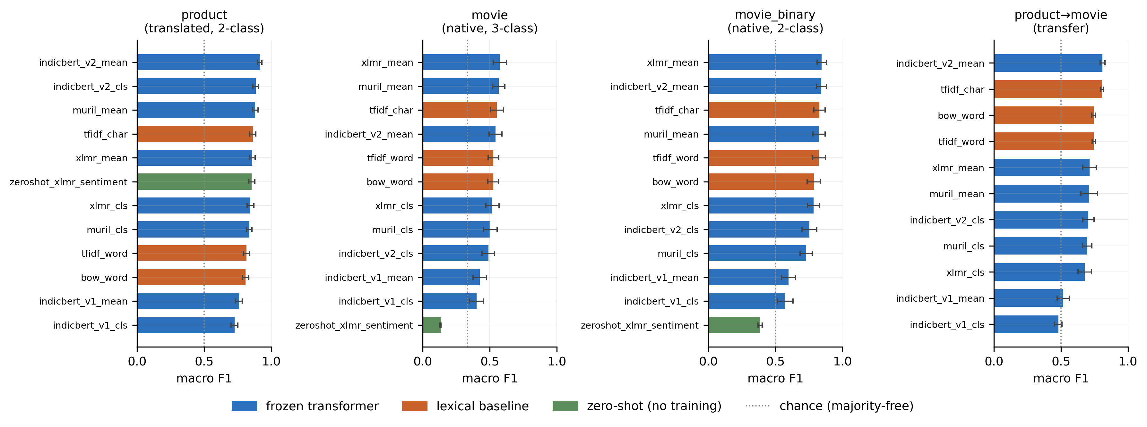
Fig. 1. Macro F1 for every feature set on each in-domain task, mean with standard deviation over 50 folds, against chance and the zero-shot arm.
6.2 The One Result That Survives Every Check
Table 6 applies the corrected resampled t-test of Section 4.7 to each task's best transformer against its strongest lexical baseline. Fig. 3 shows which claims cross α = 0.05 before and after correction.
Table 6. Best transformer against strongest lexical baseline. The naive column is the ordinary paired t-test; only the corrected column may be claimed.
Task | Transformer | Lexical | Gap | 95% CI | naive p | corrected p | Verdict
product | IndicBERT v2 mean + LR | char TF-IDF + LR | +0.0512 | [+0.0447, +0.0576] | < 0.0001 | 0.000125 | transformer wins
movie | XLM-R mean + LR | char TF-IDF + LR | +0.0219 | [+0.0061, +0.0370] | 0.0088 | 0.4626 | no detectable difference
movie_binary | XLM-R mean + LR | char TF-IDF + RF | +0.0165 | [+0.0036, +0.0294] | 0.0178 | 0.5075 | no detectable difference
product→movie | IndicBERT v2 mean + LR | char TF-IDF + LR | +0.0040 | [−0.0013, +0.0092] | 0.1442 | 0.7237 | no detectable difference

The product result is the paper's one unambiguous positive finding, and it holds up under three further checks. Tested against all three lexical baselines with a Holm correction applied within the family, it beats every one of them: +0.1008 against word TF-IDF, +0.0512 against character TF-IDF and +0.1054 against bag of words, all significant after adjustment. Choosing the winner on the first 25 folds and testing it only on the remaining 25 gives +0.0526 at a corrected p below 0.0001, so the result is not an artifact of selecting on the same data it was measured on. Its paired effect size is d = 2.17, an order of magnitude above the movie tasks' 0.39 and 0.35.
The second and third rows deserve attention for a different reason. Under the naive test both are significant. Under correction neither is. Nothing about the underlying effect changed between the two columns, the only difference is a variance factor that accounts for the folds sharing training data. This is the clearest illustration in the study of why the conventional test cannot be trusted at this corpus size, and it is why the naive column is printed at all.
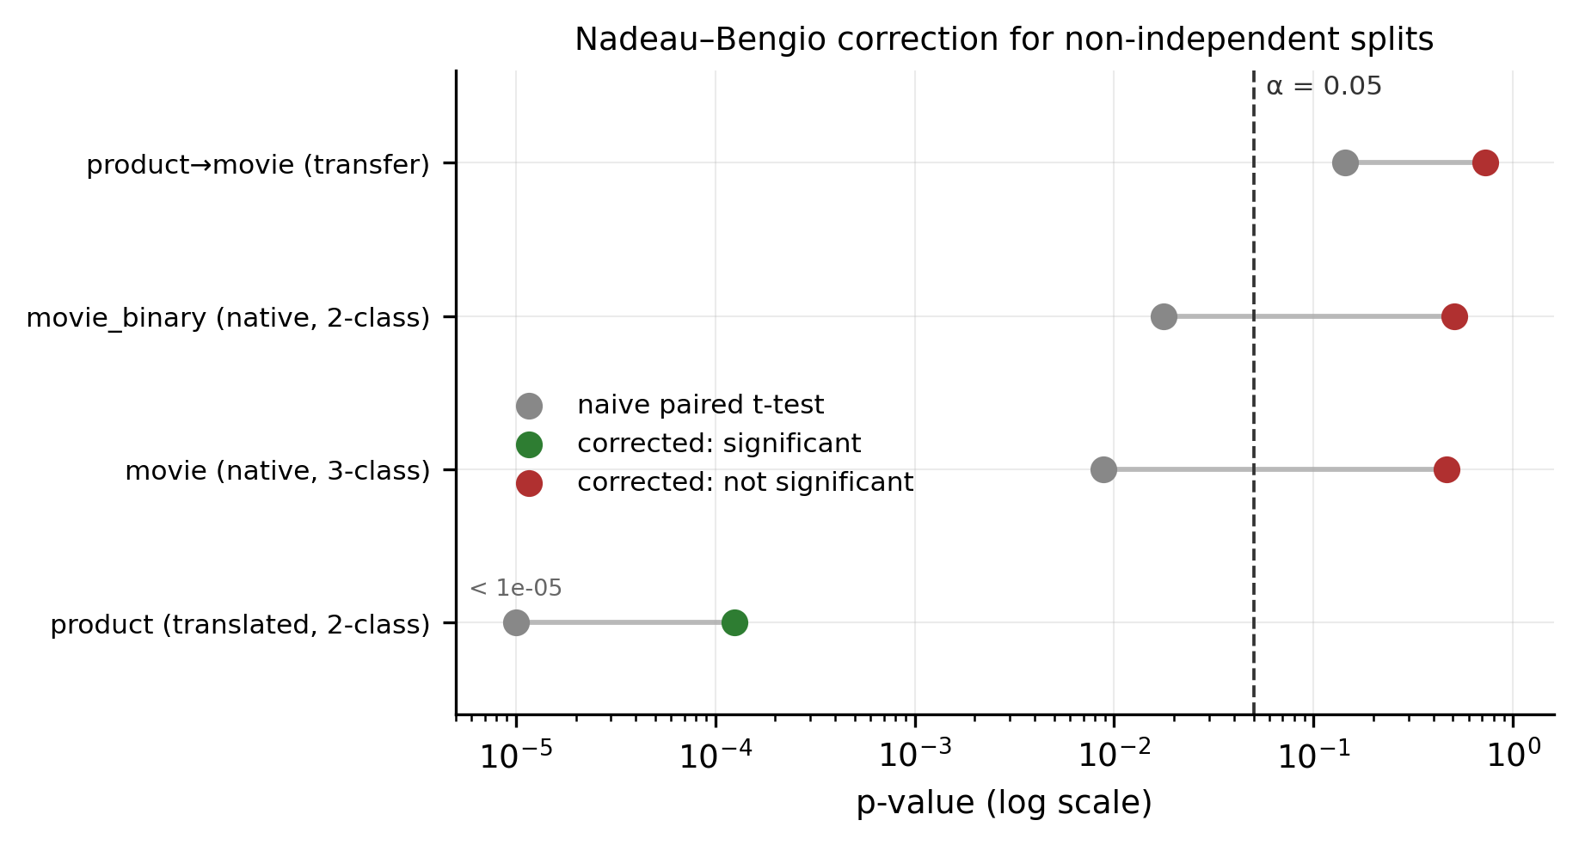
Fig. 3. Which comparisons cross alpha = 0.05 before and after the Nadeau-Bengio variance correction for reused splits.
6.3 The Translated–Native Contrast Is Not Established
The pattern in Table 6 invites one sentence: frozen encoders separate from lexical features on the translated corpus and not on the native one. That sentence compares two p-values, which tests nothing. Table 7 tests what the claim actually requires, whether the gap itself is larger on one corpus than the other, across four ways of choosing which transformer represents the transformer side. Both tasks are binary, so label-space size is not a confound. Fig. 2 plots the two gaps with their intervals.
Table 7. Interaction test. Each task is read against its own strongest lexical baseline.
Transformer side | product gap | movie_binary gap | Difference | naive p | corrected p
Best encoder per task | +0.0512 | +0.0165 | +0.0347 | < 0.0001 | 0.2131
One encoder pinned across both | +0.0512 | +0.0145 | +0.0366 | < 0.0001 | 0.2076
Mean of all four encoders | −0.0095 | −0.0504 | +0.0409 | < 0.0001 | 0.0891
Mean of the three competitive encoders | +0.0218 | +0.0095 | +0.0122 | 0.0619 | 0.6073

The difference points the same way in all four variants and reaches significance in none of them. Note also what the naive column would have licensed: three of the four at p < 0.0001, on an effect the corrected test puts between 0.09 and 0.61. Those naive values are a function of resampling 50 times rather than 10.
The third row is worth reading carefully. Averaging all four encoders makes both gaps negative, the average encoder loses to character n-grams on both corpora, and the interaction still fails. That the sign of the gap depends on whether IndicBERT v1 is included is itself a caution against summarising four encoders as "transformers".
This contrast therefore appears in Section 7 as a hypothesis, never as a result.
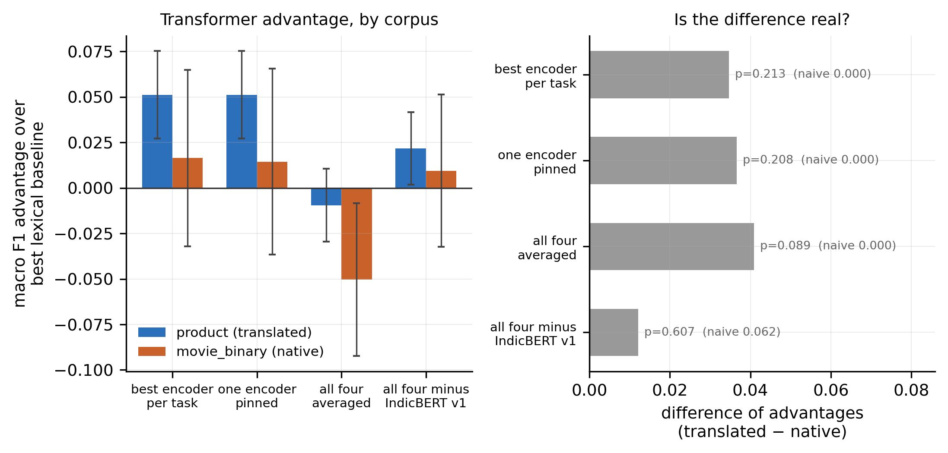
Fig. 2. The transformer-over-lexical gap on the translated product corpus against the natively written movie corpus, drawn with overlapping intervals and both the naive and corrected p-values. The contrast is a hypothesis, not a result.
6.4 What the Null Results Can and Cannot Rule Out
A non-significant result is not evidence of no effect when the design could not have detected one. On movie the smallest gap detectable at 80% power is 0.0845 against an observed +0.0219; on movie_binary it is 0.0706 against an observed +0.0165. Both observed gaps are roughly a quarter of what the study could have caught.
The honest statement is therefore bounded rather than negative: any advantage frozen encoders hold over character n-grams on native Gujarati is smaller than about 0.07 macro F1. This study cannot distinguish that from zero. The limit belongs to the corpus and not to the protocol: going from 10 estimates to 50 moved the movie_binary bound only from 0.0784 to 0.0706.
6.5 Cross-Domain Transfer
Training on product reviews and testing on the whole binary movie corpus reaches 0.8092 ± 0.0173 with IndicBERT v2, against character TF-IDF at 0.8052 ± 0.0098 and bag of words at 0.7444 ± 0.0141. The transfer score is about 96% of the 0.8445 that the best encoder reaches training in-domain on the same target, from a classifier that never saw a movie review.
The margin over the lexical baseline is +0.0040 with an interval spanning zero, so no significance is claimed for that comparison. Two further cautions apply. This is not a paired comparison against the in-domain number, since the in-domain arm tests on about 68 held-out texts per fold while transfer tests on all 340. And the spread across the transfer arm's resamples measures sensitivity to the training subsample only, because the test set is fixed by construction.
6.6 The Zero-Shot Arm
With no training of any kind, the multilingual sentiment checkpoint reaches 0.8537 ± 0.0222 on the product corpus, above both word-level lexical baselines and below character TF-IDF. It predicts 532 Negative and 619 Positive against a gold split of 572 and 579, so it is genuinely discriminating on that corpus.
On the movie corpus it scores 0.1321 ± 0.0031, and the reason is not inaccuracy. It labels 452 of 453 reviews "Neutral". On movie_binary the underlying three-way prediction is Neutral for all 340 texts, so the 0.3851 reported there is what remains after the neutral column is dropped and the decision is forced between the other two, which sends 339 of 340 to Positive. Those are the outputs of a collapsed classifier, and reporting the score without the histogram would misrepresent them as ordinary errors.
The collapse is uniform rather than graded, which is what rules out an explanation in terms of review length alone. Every text in the binary view and all but one in the three-class view received the same label, so within this corpus there is no variation in the model's output for length to correlate with. The whole corpus sits outside the distribution the checkpoint was tuned on, which was short social-media text. The finding is a boundary condition on the cheap zero-shot route and not evidence against zero-shot methods generally, a tweet-sentiment model applied to reviews averaging 1,301 characters is being used outside its design range, and a reader is entitled to say so.
6.7 Pooling
Mean pooling beats CLS pooling in all 16 encoder–task pairs: 12 in-domain and 4 in transfer. Fig. 5 plots every pair. The margins are large where the corpus is hard, 0.0897 for IndicBERT v2 on movie_binary and 0.1052 in transfer, and small but consistently positive elsewhere.
This is the study's most portable practical result. For anyone using these encoders frozen on Indic text, the CLS vector of a model trained only with masked language modelling has no reason to be a sentence summary, and the numbers here say plainly that it is not one.
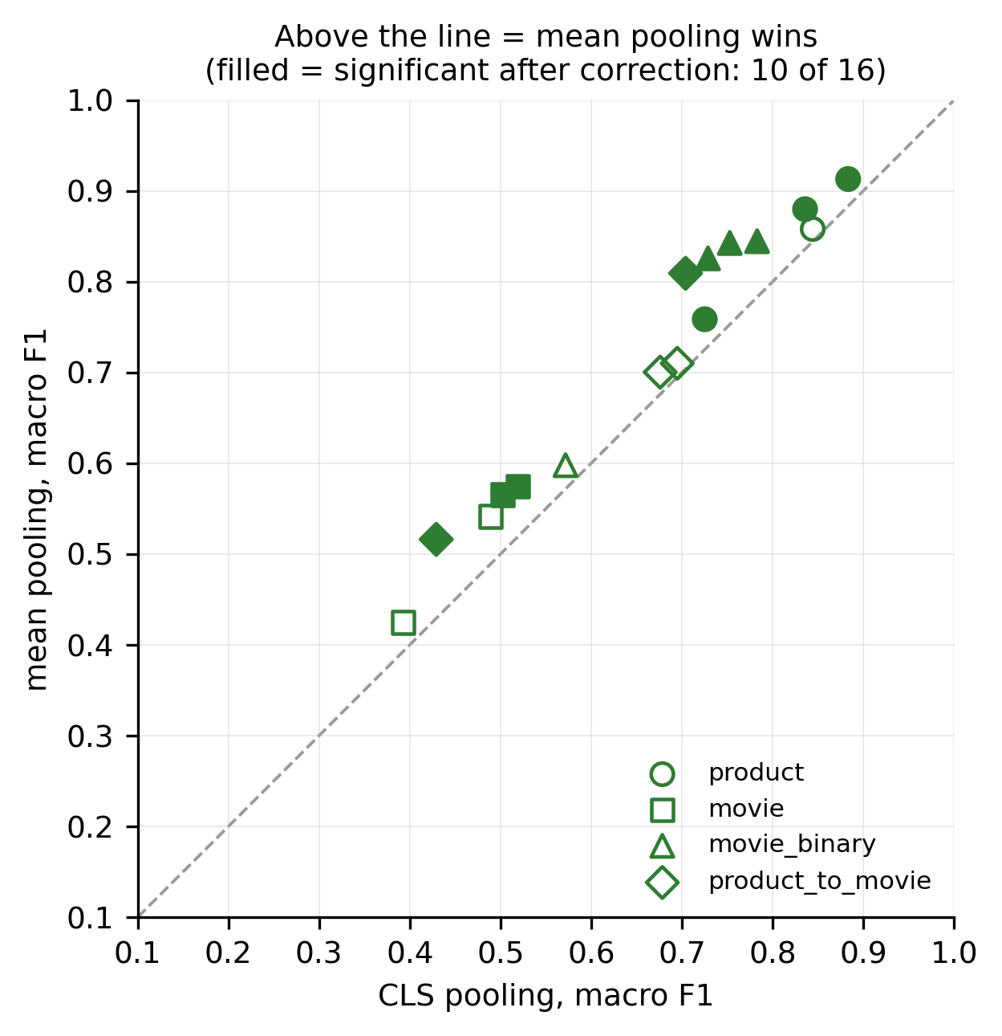
Fig. 5. Mean pooling against CLS pooling for all sixteen encoder-task pairs. Mean pooling wins every pair.
6.8 Encoder Ranking and the Fine-Tuning Inversion
IndicBERT v1 is the weakest of the four encoders on every task: 0.7586 on product, 0.4250 on movie, 0.5978 on movie_binary and 0.5162 in transfer. It loses to bag of words on all three in-domain tasks.
That inverts the published ordering. In the GSAC baselines [1], fine-tuned IndicBERT is the best of the models tested at 0.66 macro F1, while XLM-R reaches 0.39. Frozen, the ordering roughly reverses. No comparison between their absolute numbers and ours is licensed, different corpus, different regime, but the ranking inversion is a finding in its own right: how a model ranks after fine-tuning does not predict how much task-relevant structure it carries frozen.
Tokenisation does not explain it. Fig. 4 shows IndicBERT v1 and XLM-R fragmenting Gujarati almost identically, at 434.7 and 453.3 subwords per movie review, yet they sit at opposite ends of Table 5 and in the opposite order to the published ranking. IndicBERT v2 is the genuine outlier at 335.0 subwords, and it is also the strongest encoder on two of three tasks. That is a correlation worth reporting and not yet a mechanism worth claiming: with four models there is no way to separate vocabulary efficiency from the several other things that differ between them.
The two leading encoders are not separable on the native corpus. On movie_binary, XLM-R leads under cross-validation at 0.8445 and IndicBERT v2 under the holdout protocol at 0.8526, with 0.0020 between them under cross-validation. This paper therefore names no best model for native Gujarati.
6.9 Agreement Between Protocols
Every conclusion above holds under both resampling protocols. Table 8 gives the headline comparison under each.
Table 8. The same four comparisons under both protocols. Verdicts agree in every row.
Task | CV gap | CV corrected p | Holdout gap | Holdout corrected p
product | +0.0512 | 0.000125 | +0.0481 | 0.002306
movie | +0.0219 | 0.4626 | +0.0284 | 0.6166
movie_binary | +0.0165 | 0.5075 | +0.0213 | 0.4143
product→movie | +0.0040 | 0.7237 | +0.0116 | 0.2198

The interaction test fails under both, at corrected p between 0.089 and 0.607 under cross-validation and between 0.057 and 0.426 under the holdout protocol.
One disagreement is worth stating rather than hiding. The selection check of Section 6.2, run on the holdout protocol, returns a significant +0.0630 on movie_binary where the cross-validated version returns +0.0072 at p = 0.77. That check holds out five estimates under the holdout protocol against 25 under cross-validation, so the holdout version is the low-powered one and its result is best read as noise. It does not change any verdict in Table 6, and it is reported here because a robustness check that is quietly dropped when it disagrees is not a robustness check.
7. Discussion
7.1 What a Frozen Encoder Is Worth Here
The clean reading of Section 6 is that a frozen Indic encoder is worth a great deal on one of our two corpora and is not measurably better than character n-grams on the other. On the product corpus IndicBERT v2 clears the strongest lexical baseline by 0.0512 macro F1 with an effect size above 2, and it does so after a correction that removed three other apparent wins. On the movie corpus the same class of model leads by less than 0.02, which this design cannot separate from zero.
The practical consequence is unglamorous and worth stating plainly. For Gujarati sentiment on the kind of data most benchmarks contain, a single inference pass through IndicBERT v2 followed by a logistic regression is a strong, cheap system that needs no GPU and no fine-tuning corpus. For naturally written Gujarati reviews, the same pipeline gives no measurable advantage over character n-grams that cost nothing to compute.
7.2 Why the Corpus Contrast Cannot Be Attributed to Translation
The temptation is to explain the contrast by saying the product corpus is translated and the movie corpus is not. We had intended to make that argument. It does not survive contact with how the product corpus was built.
As Section 3.1 sets out, IndicSentiment reviews were not naturally occurring text that happens to have been translated. Annotators were given a curated list of aspects per product category; a different group wrote reviews against those aspects; both a positive and a negative review were commissioned for each product; and everything was composed in English before being manually translated. The source paper's own analysis describes product reviews as a one-dimensional genre in which most items are strongly polarised.
So the two corpora differ in origin, in composition language, in polarity balance, in length and in class count, all at once. Translation is one of at least four candidate explanations, and this design separates none of them. Any of the following would produce the same pattern: templated text is more internally consistent and therefore easier to separate in embedding space; deliberately polarised text is easier to classify; 130-character texts are represented more faithfully by a single pooled vector than 1,301-character texts; or translated text carries artifacts that a multilingual encoder pretrained partly on translated data finds congenial.
The last of these is the interesting one, and it is the one the literature is genuinely split on. Wein et al. [15] show that pretrained models detect translation cues without any fine-tuning, which is a mechanism by which a translated corpus could be easier for a multilingual encoder specifically. Chowdhury et al. [12] and Yu et al. [13] show translation artifacts measurably affecting downstream tasks in both directions. Against that, Kumar et al. [2] argue from the same corpus family that machine-translated Indian-language data retains the sentiment characteristics of its source well enough to build on. Our data cannot adjudicate between them, and Section 6.3 shows the interaction failing to reach significance under all four ways of testing it.
Separating these would take a design this study does not have: the same texts in a native-written and a translated version, or a corpus matched on length and polarity that differs only in origin. That is the experiment this result argues for.
7.3 Fine-Tuned Rank Does Not Predict Frozen Quality
The inversion in Section 6.8 is the finding most likely to transfer to other low-resource settings. IndicBERT v1 is the best fine-tuned model in the published Gujarati baselines [1] and the worst frozen encoder here, losing to bag of words on every in-domain task. It is also by far the smallest model in the comparison at 33 M parameters against 238 M to 278 M for the others, and an ALBERT-style model with heavily shared parameters has less capacity to carry task-relevant structure that a linear probe can reach, whatever it can be fine-tuned to do.
The practical reading is that a leaderboard built by fine-tuning is not a guide to picking an encoder you intend to freeze. Practitioners in low-resource settings routinely consult exactly such leaderboards for exactly that purpose.
Tokenisation is the obvious alternative explanation and it does not hold. IndicBERT v1 and XLM-R fragment Gujarati almost identically, and they sit at opposite ends of our results. IndicBERT v2's markedly more efficient Gujarati vocabulary does coincide with its strong performance, but with four models we cannot separate vocabulary efficiency from pretraining corpus, model size and objective.
7.4 Limitations
The native corpus is small. 453 texts, and 340 in binary form. This sets the study's binding constraint: the null arms could only have detected gaps of 0.0845 and 0.0706, so the correct claim is that any advantage on native Gujarati is below roughly 0.07 macro F1, not that there is none. No amount of resampling fixes this, since the corrected variance term is pinned by the split ratio.
One corpus per condition. Each of the two conditions is represented by exactly one corpus, so any property peculiar to that corpus is perfectly confounded with the condition. This is the deepest limitation in the paper and it follows directly from how little open Gujarati data exists.
The movie corpus is thinly documented. Its provenance, annotation process and inter-annotator agreement are not published. We report it as we found it, and a reader should weight it accordingly.
No fine-tuning, by design. Absolute scores here are not comparable to fine-tuned systems, and we make no claim about what these encoders would achieve fine-tuned. The GSAC baselines are cited for context and never compared against our numbers.
No hyperparameter search. Heads run at library defaults. A search could raise absolute scores, and on corpora this small it would add a second selection problem to one the paper already has to control for.
Two protocols, one corpus each. Cross-validation and the holdout run agree on every verdict, but they resample the same texts. Agreement between them is evidence against split-luck, not evidence of generalisation to new Gujarati data.
The zero-shot arm is used outside its design range. A tweet-sentiment checkpoint applied to reviews averaging 1,301 characters is not a fair test of zero-shot methods in general, and the collapse it exhibits should be read as a boundary condition on that specific cheap route.
7.5 What Would Move This Forward
Three things, in order of how much they would change the answer. A larger natively written Gujarati corpus would lift the power ceiling that limits every negative result here; at the current split ratio nothing else can. A corpus pair matched on length, polarity and class count that differs only in whether the text was translated would turn Section 7.2's hypothesis into something testable. And rehydrating or replacing GSAC would give the field a shared open benchmark, which is what makes results comparable across papers at all, the reason this study reports numbers that cannot be set beside the published Gujarati literature is that the only open corpus ships without its text.
8. Conclusion
This paper measured how much Gujarati sentiment structure four pretrained encoders carry without any task-specific training, using frozen representations, small classical heads, two corpora and 50 resampling folds per estimate.
One result is unambiguous. IndicBERT v2 with mean pooling and logistic regression reaches 0.9130 ± 0.0163 macro F1 on translated product reviews, 0.0512 above the strongest lexical baseline, and it survives the variance correction for reused splits, a Holm-corrected comparison against all three lexical baselines, and re-selection on disjoint folds. On natively written movie reviews the same class of model leads character n-grams by less than 0.02 and nothing survives correction. Cross-domain transfer reaches 0.8092 ± 0.0173, about 96% of the in-domain ceiling, from a classifier that never saw a movie review.
The contrast between the two corpora is the result we most wanted and the one we cannot claim. Tested as an interaction rather than as a comparison of two p-values, it fails to reach significance under every variant we ran, and the corpora differ in origin, composition language, polarity balance and length simultaneously, so translation cannot be isolated as the cause. What the null arms establish is a bound, not an absence: any advantage on native Gujarati is smaller than roughly 0.07 macro F1, and only a larger corpus can tighten that.
Two findings should carry beyond this language pair. Mean pooling beat CLS pooling in all sixteen encoder–task pairs, which is a concrete recommendation for anyone using these encoders frozen. And the ranking of these models under fine-tuning did not predict their ranking as frozen representations, IndicBERT, best in the published fine-tuned Gujarati baselines, was our weakest encoder and lost to bag of words, which is a caution for practitioners who choose an encoder from a leaderboard and then never fine-tune it.
The wider point is about how cheaply a benchmark score can be earned. A frozen encoder clears 0.90 on synthetic, templated, deliberately polarised text and cannot separate itself from character n-grams on real reviews in the same language. Whether a method works is not separable from what it was measured on, and for Gujarati the field currently has very little to measure on: the one open corpus ships without its text, and the natively written alternative holds 453 reviews. Better data, not better models, is the binding constraint on this problem.
References
[1] M. Gokani and R. Mamidi, "GSAC: A Gujarati Sentiment Analysis Corpus from Twitter," in Proc. 13th Workshop on Computational Approaches to Subjectivity, Sentiment, & Social Media Analysis, 2023, pp. 129–137. doi: 10.18653/v1/2023.wassa-1.12.
[2] S. Kumar, R. Sanasam and S. Nandi, "IndiSentiment140: Sentiment Analysis Dataset for Indian Languages with Emphasis on Low-Resource Languages using Machine Translation," in Proc. 2024 Conference of the North American Chapter of the Association for Computational Linguistics: Human Language Technologies (Volume 1: Long Papers), 2024, pp. 7689–7698. doi: 10.18653/v1/2024.naacl-long.425.
[3] P. Gupta, "A Breadth-First Catalog of Text Processing, Speech Processing and Multimodal Research in South Asian Languages," arXiv:2501.00029, 2024.
[4] R. Kumar, D. Raj and S. Saha, "BhashaSutra: A Task-Centric Unified Survey of Indian NLP Datasets, Corpora, and Resources," arXiv:2604.18423, 2026.
[5] L. Chen et al., "Cross-lingual Multimodal Sentiment Analysis for Low-Resource Languages via Language Family Disentanglement and Rethinking Transfer," in Findings of the Association for Computational Linguistics: ACL 2025, 2025, pp. 6513–6522. doi: 10.18653/v1/2025.findings-acl.338.
[6] D. Kakwani et al., "IndicNLPSuite: Monolingual Corpora, Evaluation Benchmarks and Pre-trained Multilingual Language Models for Indian Languages," in Findings of the Association for Computational Linguistics: EMNLP 2020, 2020, pp. 4948–4961. doi: 10.18653/v1/2020.findings-emnlp.445.
[7] S. Khanuja et al., "MuRIL: Multilingual Representations for Indian Languages," arXiv:2103.10730, 2021.
[8] S. Doddapaneni et al., "Towards Leaving No Indic Language Behind: Building Monolingual Corpora, Benchmark and Models for Indic Languages," arXiv:2212.05409, 2022.
[9] D. Aggarwal, V. Gupta and A. Kunchukuttan, "IndicXNLI: Evaluating Multilingual Inference for Indian Languages," arXiv:2204.08776, 2022.
[10] S. Eger, J. Daxenberger and I. Gurevych, "How to Probe Sentence Embeddings in Low-Resource Languages: On Structural Design Choices for Probing Task Evaluation," arXiv:2006.09109, 2020.
[11] R. Choenni and E. Shutova, "What does it mean to be language-agnostic? Probing multilingual sentence encoders for typological properties," arXiv:2009.12862, 2020.
[12] K. D. Chowdhury et al., "Towards Debiasing Translation Artifacts," arXiv:2205.08001, 2022.
[13] S. Yu et al., "Translate-Train Embracing Translationese Artifacts," in Proc. 60th Annual Meeting of the Association for Computational Linguistics (Volume 2: Short Papers), 2022, pp. 362–370. doi: 10.18653/v1/2022.acl-short.40.
[14] C. Park et al., "Translation Deserves Better: Analyzing Translation Artifacts in Cross-lingual Visual Question Answering," arXiv:2406.02331, 2024.
[15] S. Wein et al., "Lost in Translation, and Found: Detecting and Interpreting Translation Effects," in Proc. 64th Annual Meeting of the Association for Computational Linguistics (Volume 1: Long Papers), 2026, pp. 17172–17187. doi: 10.18653/v1/2026.acl-long.781.
[16] J. Kunz, "Training Models on Dialects of Translationese Shows How Lexical Diversity and Source-Target Syntactic Similarity Shape Learning," arXiv:2602.16469, 2026.
[17] C. Du et al., "Adversarial and Domain-Aware BERT for Cross-Domain Sentiment Analysis," in Proc. 58th Annual Meeting of the Association for Computational Linguistics, 2020, pp. 4019–4028. doi: 10.18653/v1/2020.acl-main.370.
[18] F. Yang, A. Mukherjee and Y. Zhang, "Leveraging Multiple Domains for Sentiment Classification," in Proceedings of COLING 2016, the 26th International Conference on Computational Linguistics: Technical Papers, 2016, pp. 2978–2988.
[19] G. Lai et al., "Bridging the domain gap in cross-lingual document classification," arXiv:1909.07009, 2019.
[20] J. Guo, D. J. Shah and R. Barzilay, "Multi-Source Domain Adaptation with Mixture of Experts," arXiv:1809.02256, 2018.
[21] R. Dror et al., "The Hitchhiker's Guide to Testing Statistical Significance in Natural Language Processing," in Proc. 56th Annual Meeting of the Association for Computational Linguistics (Volume 1: Long Papers), 2018, pp. 1383–1392. doi: 10.18653/v1/P18-1128.
[22] D. Card et al., "With Little Power Comes Great Responsibility," in Proc. 2020 Conference on Empirical Methods in Natural Language Processing (EMNLP), 2020, pp. 9263–9274. doi: 10.18653/v1/2020.emnlp-main.745.
[23] N. Reimers and I. Gurevych, "Reporting Score Distributions Makes a Difference: Performance Study of LSTM-networks for Sequence Tagging," arXiv:1707.09861, 2017.
[24] C. Nadeau and Y. Bengio, "Inference for the Generalization Error," in Advances in Neural Information Processing Systems, vol. 12, 1999.

